PROPERTY MANAGEMENT APPLICATIONS

# INTRODUCTION

## OVER VIEW

* Develop an app for the Property management where Buyer can order his Requirements and get the Appropriate Details of the Property.
* According to his interest just provide him with some discounts upto what extent he can get the discount.
* Also Track Whether he is Interested in taking the loan available for so just calculate how much loan amount user can get it.
* Provide the Security for to different profiles like for marketing and sales team.
* Then Finally Create the reports and dashboard so the will be clear view just get the reports on count of loan passed getting the property purchased close the deal.

## PURPOSE

* As Property Management software allows you to record expenses, log payments, digitize receipts, and generate financial reports, it becomes easier to file taxes as everything has been stored.
* Managing properties takes a lot of time and effort, and there’s so much to keep track of. Find out how property management software can simplify these process today.
* Property managers assists owners in creating budgets, advertise rental properties, qualify tenants, and collect rent.
* A property management system is a software application for the operations of hospitality accommodations and commercial residential rental properties.
* Property management system is also used in manufacturing industries, local government and manufacturing.

# 2 PROBLEM DEFINITION & DESIGN THINKING

## 2.1 EMPATHY MAP

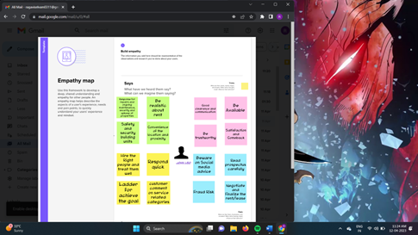

## 2.2 IDEATION & BRAINSTORMING MAP

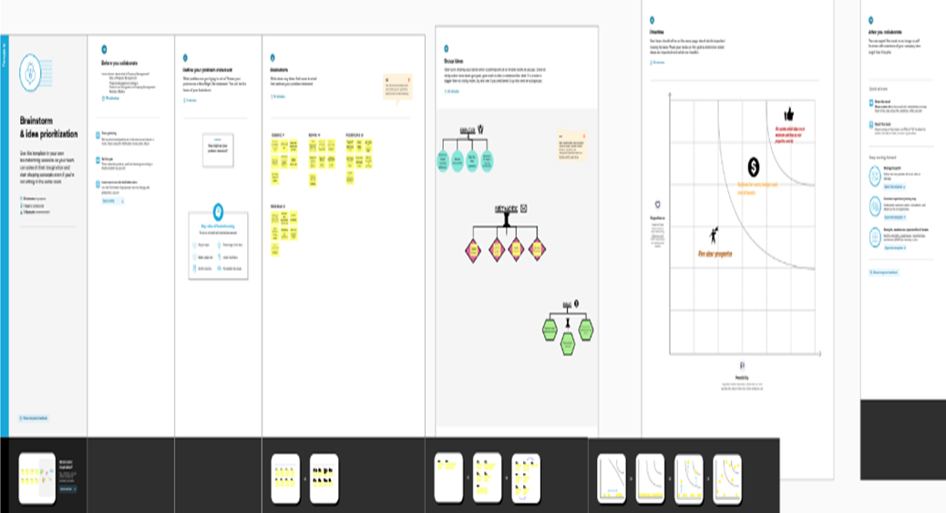

# RESULT

## DATA MODEL:

|  |  |
| --- | --- |
| **OBJECT NAME** | **FIELD IN THE OBJECT** |
| BUY | |  |  | | --- | --- | | Field label | Data type | | Buy | Picklist | |
| RENT | |  |  | | --- | --- | | Field label | Data type | | Rent | Picklist | |

|  |  |  |  |  |  |
| --- | --- | --- | --- | --- | --- |
| LOAN | |  |  | | --- | --- | | Field label | Data type | | Loan | Auto number | |
| LEAD | |  |  | | --- | --- | | Field label | Data type | | Lead | Auto number | |

# 

# ACTIVITY & SCREENSHOT

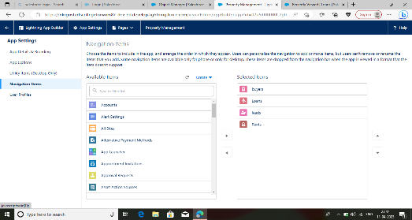

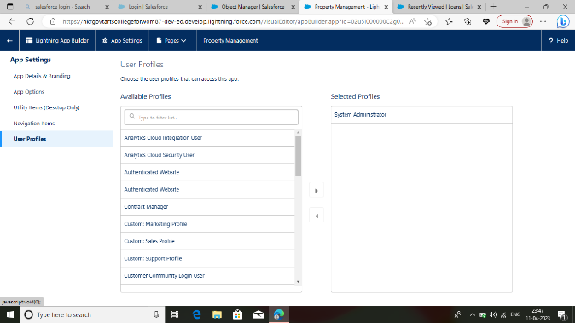

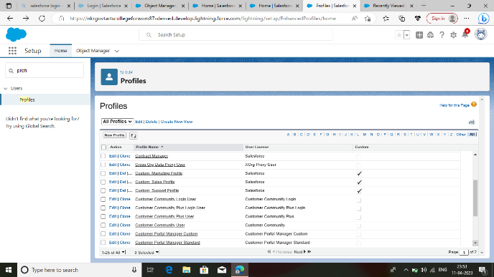

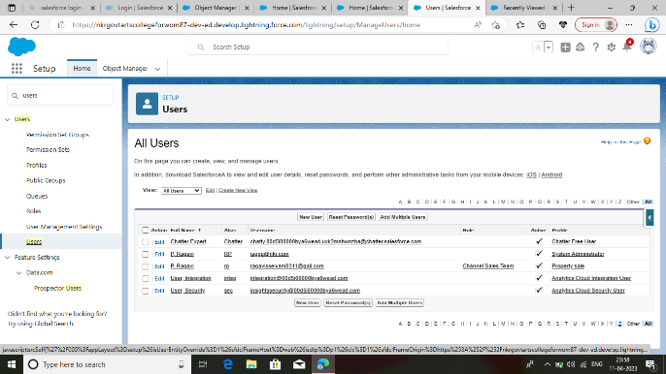

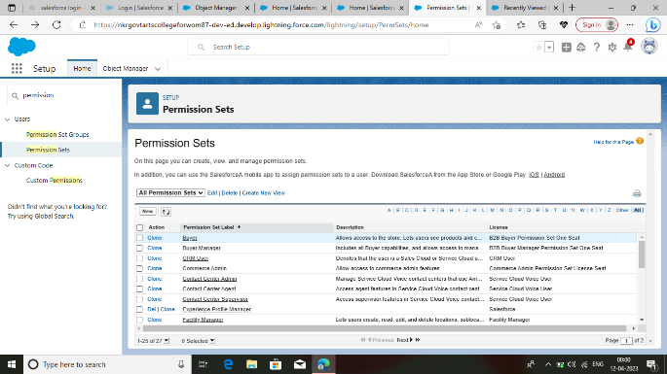

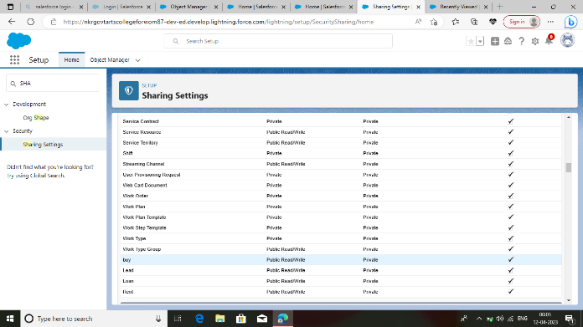

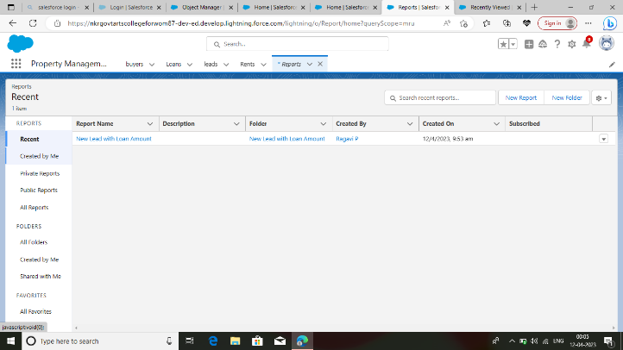

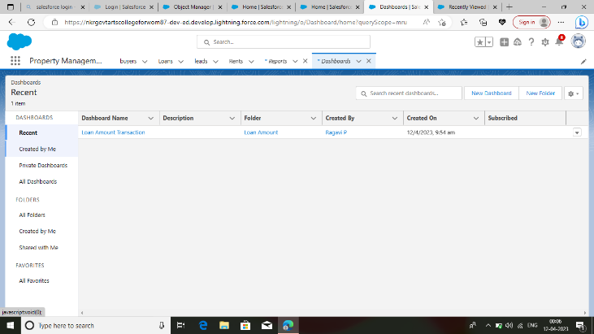

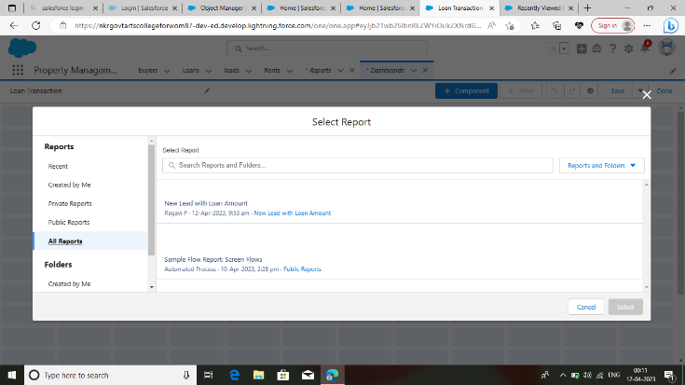

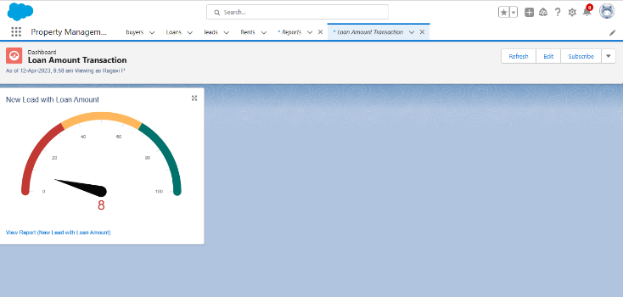

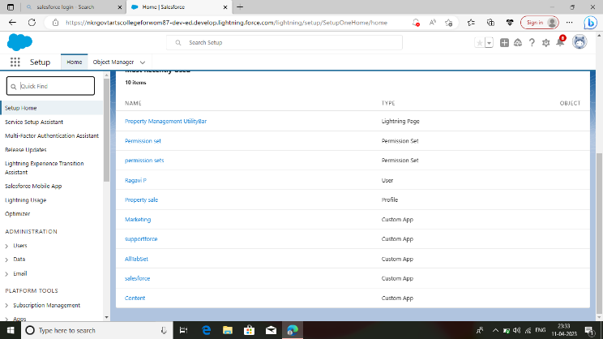

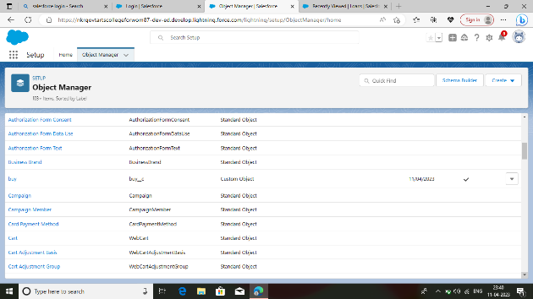

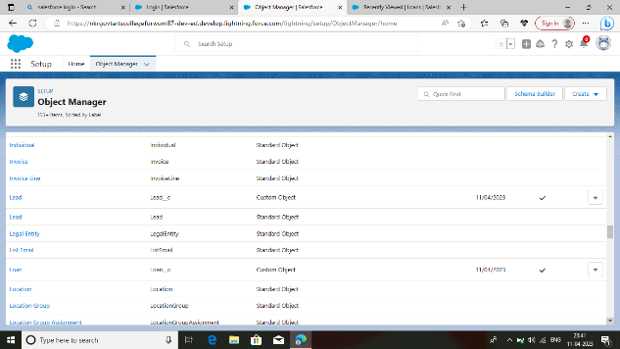

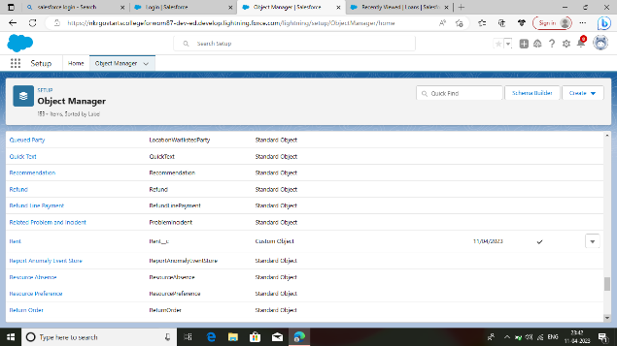

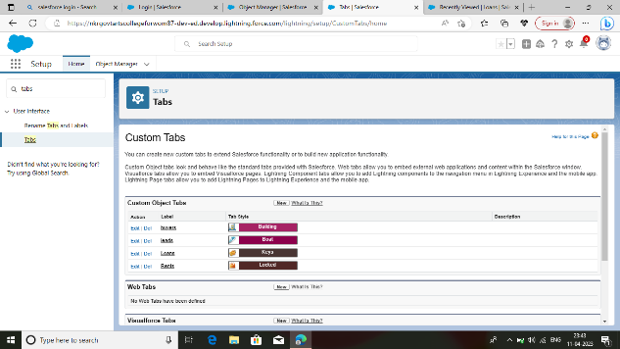

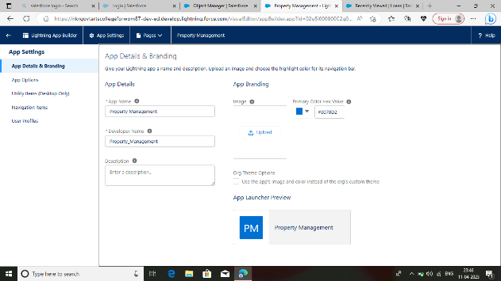

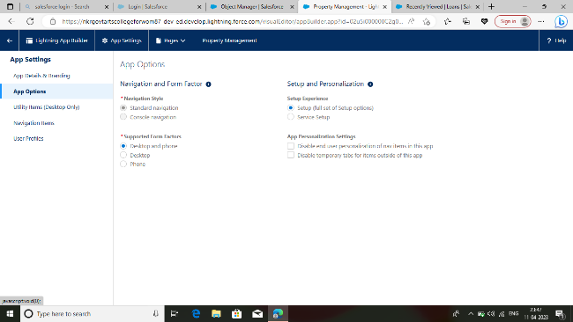

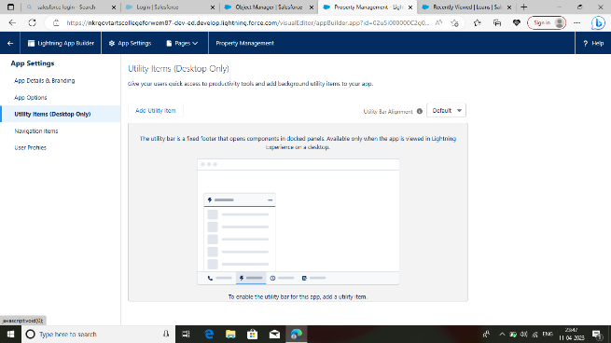

# TRAILHEAD PROFILE PUBLIC URL

P. RAGAVI

<https://trailblazer.me/id/ragavipanneerselvam>

M. RAMYA

<https://trailblazer.me/id/ramyam23>

G. POORNIMA

<https://trailblazer.me/id/poorg69>

S. PRAVENA

<https://trailblazer.me/id/pravs64512>

# ADVANTAGES & DISADVANTAGES

## ADVANTAGES

 Maintenance management and tracking

 Tenant applications and screenings

 Online payments

* Contact management
* Advertising and marketing
* Financial management
* Reduce time spend on admin

## DISADVANTAGES

 It could take a lot of man-hours to train staff on how to use it.

 Time consuming if you choose the wrong system

 Might seem expensive for a small business

 The risk that employees will take there new found management skills to a higher-paying

competitor

# 6 APPLICATIONS

# 

Manage rental properties and tenants

 User-friendly and easy to navigate

 Search by locality / property type

 Book a visit to shortlisted properties

 Manage rent agreement

# 7 CONCLUSION

In conclusion, Property Management System software is very crucial for all the properties. Especially opera PMS constitutes the most appropriate PMS software for Hilton Athens. It is user-friendly, connects with Central Reservation system, point of sale etc., and provides all the tools properties needs in order to operate effectively.

# 8 FUTURE SCOPE

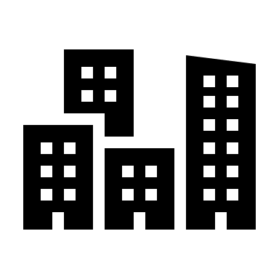 Property managers’ work became very appreciated when the world started to suffer a

Pandemic.

 Property managers were underrated until their services were imperative to keep rental

Properties above water.

 The twenty-twenties have assured a new era of property management, and here’s what

We see now and predict more of in the future of property management.

 When there is better communication between managers and clients, it opens up a

Whole world of opportunities for new services and benefits.